LAHORE GARRISON UNIVERSITY



Name: Hiba Ahmed
Roll No. FA2024/BSSE/172
Section: A
Semester: 4th
Subject: Software Construction & Development
Submitted to: Dr. Ali Haider
Use Case Diagram
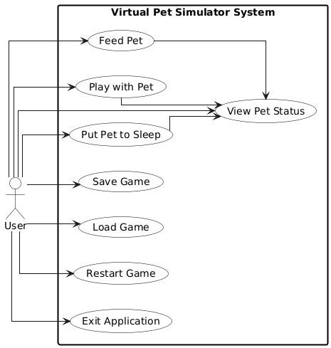

Class Diagram
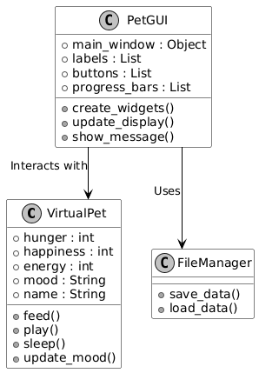

Activity Diagram
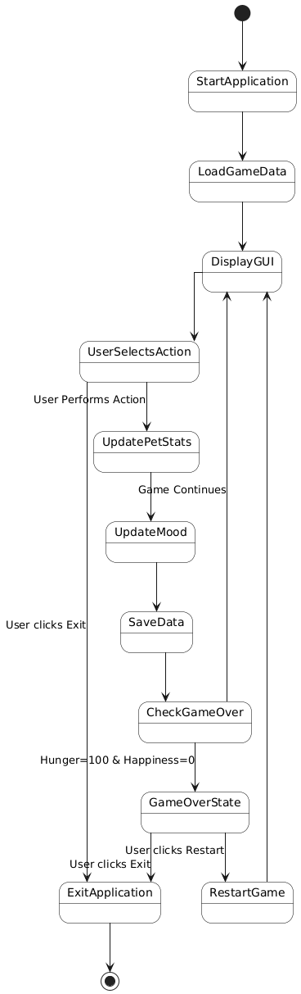
Sequence Diagram

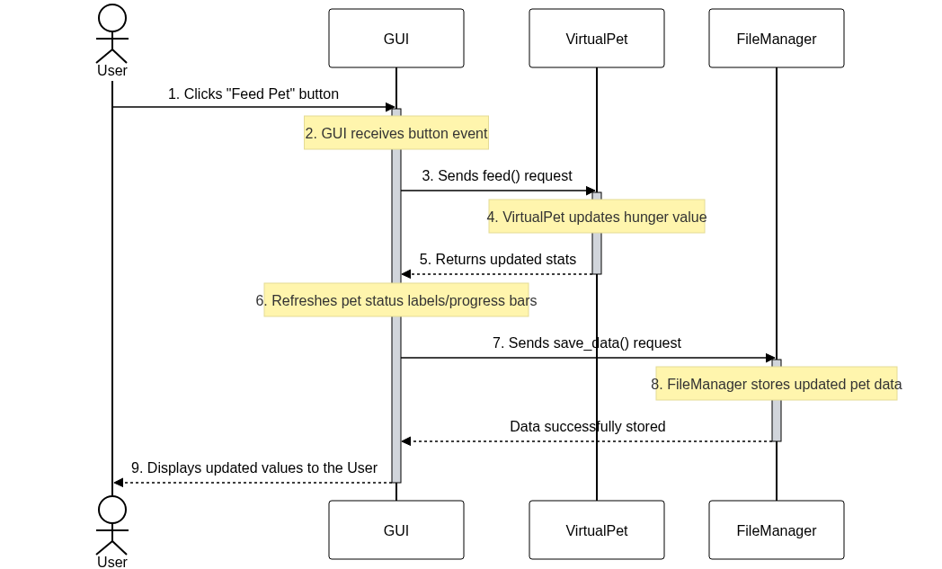

State Diagram
